Internship start document

(*Front end intern)*

Student: Muskan Bhat

Student ID number: 636130

Degree programme: Bachelor’s Information technology

Email address: company [ssg@ythewait.com](mailto:ssg@ythewait.com)

Client: Y the wait

Company supervisor: Simranjit Singh Grewal

Supervising lecturer: Eef Stavenuiter

Place: Rivium 4e Straat 3, 2909LJ Capelle aan den Ijssel

Date: 11-12-2020

Version: Final

Contents

1. Introduction 2

2. Company orientation 2

3. Action plan 3

3.1. Assignment description 4

3.1.1. Description 4

3.1.2. Scope 4

3.1.3. Conditional requirements 4

3.2. Approach 4

3.2.1. Products to be delivered 4

3.2.2. Approach: activities to be undertaken 5

3.2.3. Quality assurance 5

3.2.4. Schedule 6

3.2.5. Organisation 6

4. Chosen competences and learning objectives 6

Design Competency 7

Professionalization Competency 7

5. Appendices 7

5.1. Contact Details 8

5.2. Gantt Chart 9

5.3. Interviews 10

Interview ICT employee: Varun 10

Interview ICT employee : Sumit 11

Summary 11

Reflection 12

# Introduction

This is the start document for the front-end internship I have started in “Y The Wait Operations BV”. My assignment is mainly divided into two parts. The first part consists of development of front end of the websites for businesses(merchants) registered with Y the wait. The merchants can be classified as restaurants, hotels, supermarkets, pharmacies, etc.

The second part consists of re-development of the front end of the website of backend dashboard for the clients. The existing version of admin dashboard uses front-end technologies HTML5, jQuery, and bootstrap and wanted to switch to ReactJS. It involves upgrade of the existing features of the dashboard as well adding new features in the dashboard.

Therefore, the company could use a front-end intern.

The document is intended to provide an in-depth insight of my internship period details for the student, the supervisor, and the company as well. This would be useful to keep track of my progress during the internship and would be useful to gain insight of what exact planning and objectives of my internship period will be.

This document consists various parts mainly divided in 5 parts,

* Company Orientation
* Action Plan
* Approach
* Competences
* Appendices

# Company orientation

Y the wait is an extensive platform developed to provide hospitality features to various types of customers. The customers of the company include the an app user that uses app to access hospitality services of the business owners registered with Y The Wait, and the businesses registered with the company including restaurants, hotels, supermarkets, event halls, etc. The basic module contains the digital waiter service, delivery/takeaway/reservation, and exclusively for business owners, are the services like point of service software, staff app, etc.

The vision of Y the wait is to become the global dynamic leader in the hospitality industry through innovative solutions and their mission is to transform the way people experience their hospitality service globally. Their goal is to deliver everyone the food and service that they deserve in an honest and easy way. The core values that represent the company strongest are: Integrity, transparency, and a family-oriented company culture.

Company’s management philosophy is based on responsibility and mutual respect. They wish to maintain a work environment that fosters on personal and professional growth for all employees. Maintaining such an environment is the responsibility of every staff person. Because of their role, managers and supervisors have the additional responsibility to lead in a manner which fosters an environment of respect for each person.

The company is currently spreading globally, currently established in The Netherlands, Canada, USA, India, Lebanon, etc with over more than 7000 businesses registered with the company.

The technologies used by the company’s development teams involve HTML, JavaScript, PHP, CodeIgniter Framework, Reactjs, Redux, etc.

The Business model of Y The Wait is Peer to Peer which means that the end customer and merchants or vendor interact to buy sell services directly with each other without an intermediary third-party.

Y the Wait provides a lot of services via their platform, as it is aimed to serve as an all-in-one app for both business owners and app/website user who want to access their services. They do have competitors as well but having a wide range of facilities being provided makes them, unique in their field. However, some apps that provide similar services such as food ordering in The Netherlands are Thuisbezorgd, Uber eats, etc.

The services of Y the Wait are all about evolving hospitality service experience, it serves to eliminate all inconveniences people experience during a restaurant dine-in or a home delivery order. The app minimalizes waiting time in restaurants when you are craving for food.

* Service and food reinvented.
* Easy and user-friendly table planner
* Automatic allocation of tables available
* Allots a limitless number of rooms and tables
* Arrangement of the tables for large-scale events and parties

The main service Y The Wait provides to their clients is the User app and the ordering website. Meanwhile there are certain tools the company provides to the merchants to use their services, which can be classified as point of sale, the staff app, individual ordering website and the dashboard. The dashboard is a web-based admin panel used by the business owners such as any restaurant, supermarket, or hotel registered with Y The Wait, and is also used by the company data management team.

Moving on, the individual ordering websites provided to the merchants are used by the website users to access the products are services provided by the merchants. Each type of business has different template of ordering website depending on the type of services they provide, for example the ordering website for a merchant who has a restaurant registered would differ from the website for a supermarket and so on.

The dashboard has various purposes like registering businesses, entering data for the business owners, access to manage features like delivery, takeaway, reservations, discount coupons, revenue reports, and more essential functions.

Next up, is the user ordering platform, available in website and app versions is used for customer to prevail services provided by the business owners, for example a user can log in the user app, look for restaurants near them, order food for delivery or takeaway, reserve a place in the restaurants.

Further, the Point of sales, also available in website and app both are the platforms used by the business owners to manage their stocks, their, products, staff, revenue, reservations, orders, etc. Further, the staff app is used by waiters and delivery persons to keep track of the tasks assigned to them by their employer.

# Action plan

The first part of my assignment consists of building front-end for ordering website templates for different kinds of merchants registered with Y the Wait. The merchants can be classified as restaurants, hotels, supermarkets, pharmacies, etc.

The second part of the assignment consists of performing a technology shift by rebuilding the front-end of the web-based dashboard of the Y the Wait. As Super-admin dashboard consists of various modules the assignment will further be divided into smaller segments.

## Assignment description

### Description

To start with the first part of my assignment consists of making front end of the websites for the merchants based on the different design templates provided which will differ based on the business type of the merchants. The websites will be developed in HTML5, CSS, bootstrap, and Java Script. It is an essential necessity for the businesses registered under Y the wait as these websites are the way website users would be able to view their products or services.

As every business type has a different kind of ordering website template to choose from, the assignment will be extensive and collaborative. I will receive the design from our design team, and I will have to make the first template. After that it will get check by my senior developer colleague(s) and the website will go live after the backend functionalities are integrated as well.

Next, as described earlier, the assignment is to rebuild the front end, which is entirely made up of HTML5, jQuery, and bootstrap. The goal is to eliminate jQuery and rely entirely on JavaScript es6 and react with redux.

The super-admin dashboard is used by clients, be it business owners or the administrators of the website. It has access levels based on roles. As Y The wait is a globally growing company it’s reaching more and more customers every day, and this is why advancement of the product was required as the current website design is reportedly slower and primitive and therefor it was decided to re-build the front-end using react which is relatively faster and advanced to support a vast range of customers. Hence this part of the assignment solely focuses on improvement of the dashboard for convenience of the future and present clients.

### Scope

The scope of the front-end development of the ordering websites assignment is building website template based on the design provided by the design team for different types of businesses registered with Y the wait.

Meanwhile, the scope of the other assignment is to re-develop entire dashboard which consists of 15 sub-modules currently and will probably add few more sub-modules in the future. The admin panels of the dashboard have a wide range of usage. It is used for overall management of the businesses by business owners and the admins of the dashboard. Some modules of dashboard can be described as Restaurants/Stores (registration, data entry), Requests (business registration requests), Orders management, Discounts coupons, Revenue reports, etc.

### Conditional requirements

For the front-end development of the ordering website I will work with familiar technologies, but I am rather inexperienced with bootstrap so I will use some tutorials and help from my senior colleagues for the development.

As the front-end development of the dashboard will be using React Native and redux there for the preconditions of the starting with the assignments are knowledge of ES6 and React JS and Redux. The project leader and the company will give trainings and be providing learning material or additional support if required.

## Approach

### Products to be delivered

The final product to be delivered consists of various steps, which we can classify as interim products. Interim products will be both the assignments combined, the ordering websites and the dashboard.

The assignment will consist of firstly building front end of ordering website templates for different kinds of merchants. And the other one consists of shifting dashboard front end technology to React redux for better compatibility. Which will further be followed by implementing functionality to that structure. The functionalities are further divided in to 5 main categories, customer registration, Data entry, Delivery/Takeaway/Reservation, Discounts, and Invoices.

My approach towards completing my assignments defined according to SMART goals setting would be,

Specific: My assignments are, first, developing the front-end for both the ordering websites for the merchants/business owners registered under Y The Wait using HTML5, CSS, JavaScript and bootstrap, and the second, developing the front end for the admin dashboard for which I need to have knowledge of ES6, React JS and Redux. In both assignments it would be provided the design prototype based on which I will develop the front end respective to both the assignments.

Measurable: I will be provided a design of the web pages consisting in the website and I have to deliver one website with 1-2 weeks depending upon the type of website template I am working on for example if it is an ordering website for a restaurant or a department store, the design and requirements will vary. Same goes for the module development in the dashboard assignment, the time for development will vary from module to module and it will also be something I will be working on first time on the professional level, but it will be developed according to the deadline and time provided to me by my project manager.

Attainable: The goals and expectations from me will be clear, and I would be are of what and how much is expected from me. I will also be provided feedback from my senior to guide about the quality of work I should deliver.

Relevant: The relevance of these assignments is high as my work will be integrated in company’s main services after it is checked by my senior developer colleague(s) and the websites will go live after the backend functionalities are integrated. Both Ordering websites and dashboard are included in main services of Y Th wait. And Woking on such important and interesting projects will give me a sense of responsibility and experience with professional development skills.

Time-Based: My assignments will be divided into smaller task. I will be given weekly goals to fulfil, further divided in daily tasks and I will report every day and in the end of every week as week to inform about my progress.

### Approach: activities to be undertaken

The activities to be undertaken is learning to work with bootstrap, reactJS and redux first.

After that, I can move on to developing the front end of ordering websites and dashboard platform, respectively.

### Quality assurance

The quality of work delivered will be supervised by the senior developer and the project team. They will check my work, provide feedback and necessary help. After the back-end technologies are integrated with the front end I developed and the testing is done, the websites will go live that means my work will be an essential part of the company’s services.

Daily targets will be set for me and I must report at the end of everyday if I met them or not and if not, then what are the issues I faced.

Weekly meetings will be helping to discuss the work done, feedback and for discussing next step of the assignment.

### Schedule

For the first 3 weeks, I will prepare myself so I could understand React and redux since this will be my first-time developing in ReactJS. After finished with my training, I will start with development of ordering websites and receive bootstrap training side by side from my colleague and lessons available online. And lastly, I will get into the development of the dashboard.

The schedule of activities consisted in the assignment are represented by a Gantt chart will be added as an appendix to the action plan.

### Organisation

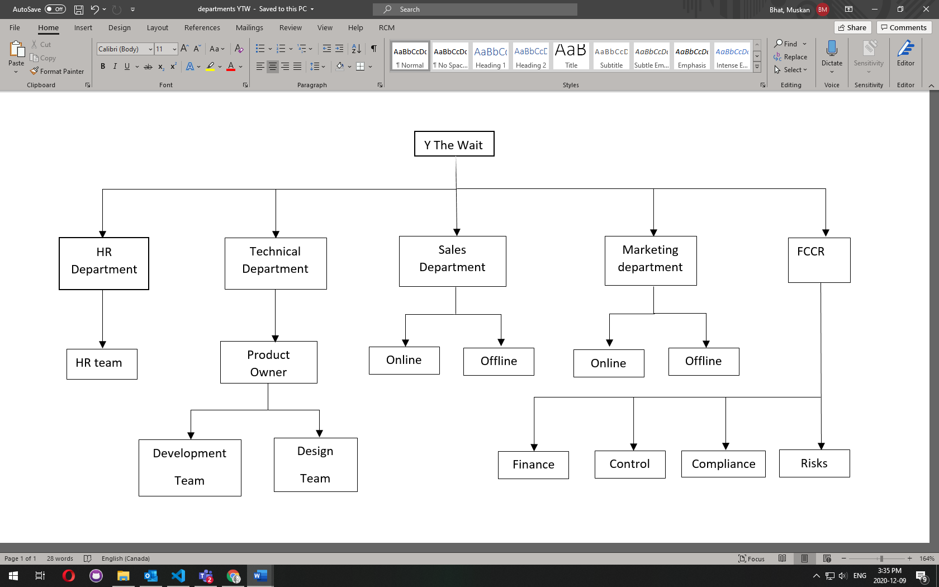

# Chosen competences and learning objectives

Learning Objectives

Following are the learning objects I wish to consider in my internship period:

* Work experience in a professional work environment

This is an essential objective for me as it is my first workplace. Therefore, I want to adapt in the workplace etiquette and get insight of professional work environment.

* Working as a part of a team

I have already worked as a team member but this time it will be in a working environment so I am assuming it will be bit different to collaborate as most of my team members are in India so our communication will be online while I will be present in the Netherlands office. I want to be able be a good team player and be able to keep up with quality of work I deliver and the deadlines.

* Learning front-end technologies

As I mentioned earlier, the first assignment will require me to use bootstrap mostly so I will obtain practical experience with bootstrap. For the second assignment I will be working with React JS. React is an open-source JavaScript library for building user interfaces or UI components. During this internship I aim to be experienced in React development.

And therefore, the competences I aim to achieve are, Design and Professionalization.

## Design Competency

In both parts of the assignment, I will be working on development of the front end using different technologies which is a great chance for me to learn working with two different kinds of projects and frameworks. I will be learning to develop the front end in bootstrap, reactjs and redux which is very new for me as for my college assignments I have not worked with these. This internship is a chance for me get hands on experience to bring the design of the front-end alive in code which will be further included in actual live websites of Y The Wait, for both the order website templates and the dashboard.

## Professionalization Competency

I intend to work and collaborate effectively as a team member in a professional working environment. I also worked in project groups for college assignments I did with my classmates and could work as a good team player with them but I have t develop my communication skills, but not yet on the professional level. My assignments will be divided in daily goals which add up to become my weekly task. I must report every day to my project manager informing them about my daily task completion or any issues that hindered it. At Y the wait uses a platform called Basecamp to communicate between the teams, to record everyone’s daily tasks, to provide tasks to other team members as to-dos which they can check when tasks are completed. In the end, I am aiming to have gained experience as working as a team member in a professional team and communicating within a team.

# Appendices

Additional texts, charts and results, etc. will be included in the appendices. Reference must be made to this extra information in the main text. The following appendices must be included at the very least:

* Interview reports;
* A Gantt chart;
* The contact details document.

## Contact Details

Varun Dhamija

Position: Web development team leader

Phone number: +91 95697 91259

Gurleen Kaur

Position: Associate project coordinator

Phone number: +91 75279 00797

Divya Chauhan

Position: Frontend Developer

Phone number: +91 8437420894

Simranjit Singh Grewal

Position: CEO, On site supervisor

Email: [ssg@ythewait.com](mailto:ssg@ythewait.com)

Navjinder Singh

Position: Operations head, On site supervisor

Email: [navjinder@ythewait.org](mailto:navjinder@ythewait.org)

## Gantt Chart

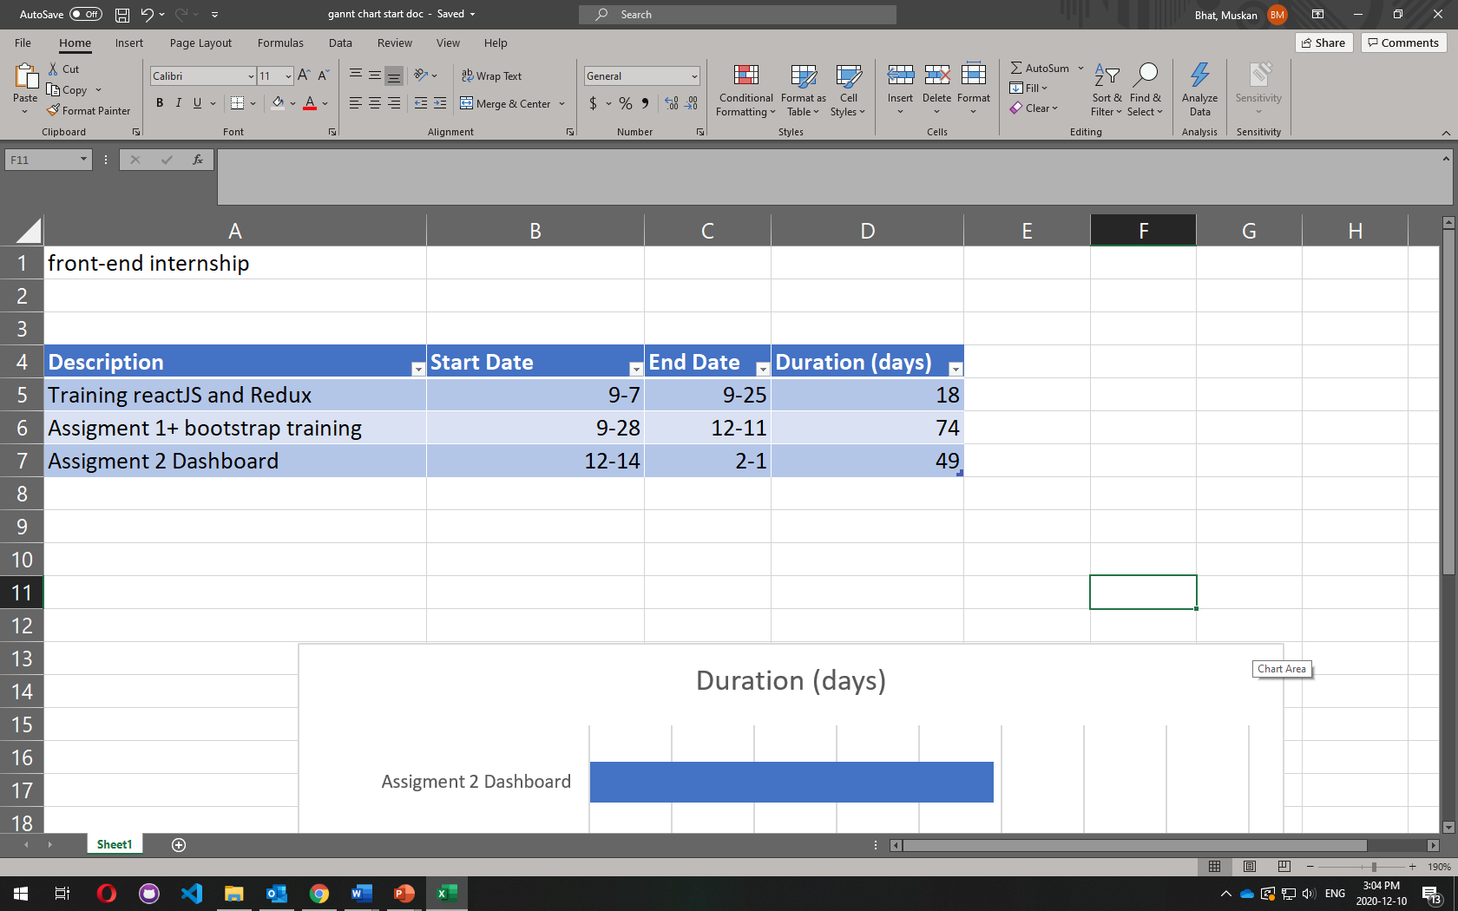

## Interviews

I conducted two interviews, one with the senior web developer and Team Leader of Y the Wait web development team, Varun and other with senior web developer Sumit, who I will be working with alongside during my assignment 2 dashboard project.

I prepared a list of questions for them and asked them to fill in their answers accordingly. The interviews were brief but I did gain some important insights about working in a professional IT environment.

### Interview ICT employee: Varun

Personal Insights

What is your position working at Y the Wait?

Sr. Web Developer, Team Leader

What is your educational background?

12th standard, High school.

Can you give me a brief insight into your professional career?

I do have a keen interest in coding and started the same at an early age after 12th, and now I have successfully gained 8 years of knowledge and experience in this web development strait.

What are some important things you would advise me as a complete beginner in the ICT field?

1. Almost every IT job requires good communication skills, both verbal and written – email communication will likely be a big part of your job.

2. Multitasking can be an important skill – but only if you can properly organize yourself. The ability to keep track of things such as your schedule and daily tasks is essential

3. Being analytical gives you a major edge in IT, where you're expected to find logical solutions to problems frequently.

4. As an IT professional, chances are, you'll be juggling multiple projects and responsibilities, and being able to meet deadlines and hit benchmarks is critical.

5. A lot of the technical skills you need for various careers in IT can be picked up through tinkering and trial and error, so problem-solving abilities are necessary for your entrance into the field.

What are some pitfalls of ICT industry based on your experience in the field?

1. The hours are long

There are all sorts of IT jobs, but most of them have one thing in common: They involve working long hours. If you want to work in IT, you better be prepared to work nights and weekends.

2. Work tends to be deadline-driven

3. Things don't always work the way they're supposed to

4. People expect you to fix their home computers

5. Your personal time will be interrupted

### Interview ICT employee : Sumit

Personal Insights

What is your position working at Y the Wait?

Ans. Sr.Web Developer

What is your educational background?

Ans. MCA

Can you give me brief insight about your professional career?

Ans.

I started my careers since 2015 as a PHP Developer and created 10-12 websites in php with multiple frameworks like Cakephp, Laravel and Codeigniter. Currently working on react js and codeigniter.

Can you tell me about some of your important projects while working in the ICT industry?

Ans. The Upbeet kitchen, LinkedIn Scraping, ECAhub, Ateen, Ythewait

What are some important things you would advise me as a complete beginner in the ICT field?

Ans.

Grab the knowledge of different technologies and work on that to take experience

Don’t be afraid to try new things and look for resources for learning new things

Never stop learning in the IT field

What are some pitfalls of ICT industry based on your experience in the field?

Ans.

The learning never stops which is sometimes tiring

Work can sometimes leave us with little time for ourselves

Assignment

Why did the dashboard require remodelling according to you?

Ans. The dashboard needs advancement in design, and it needs to be remade in react to be compatible for increasing users.

What are technical skills required in successful execution of this assignment?

Ans. React JS, HTML, CSS, Es6

### Summary

From the first interview with my team leader, I got helpful advices and a lot of valuable information on working in the ICT industry. His professional carer is so impressive and inspirational. He told that being communicative, multitasking, analytical and developing problem solving abilities is important for a as a beginner in ICT field. Also, according to him some pitfalls of being in the IT industry are, long work hours, deadline driven work, unexpected turn of events and less time for your personal life.

In the second interview with my colleague senior web developer, his professional career includes of an impressive variety of web technologies he has worked with and has a lot of experience as well. He has worked with some interesting projects in his career. He advised to gather as much as knowledge and information and to keep learning news things. The pitfalls he mentioned were also recognisable as he said learning never stops which can be tiresome and they have less time for themselves.

### Reflection

One important thing I realized from the interviews was that experience has a greater value than education for sure in the IT field. The more knowledge and experience you gain, the more successful one could be in IT filed. Also, I totally agree with my team leader saying that factors like communication, multitasking and being analytical because they are some essential life skills one need to develop and incorporate in their lives. Communication has been and essential factor I need to work on and get used to for my professional life for sure.

Also, both of the colleagues mentioning that in IT jobs, it is difficult to get time for yourself, I would try to keep that in mind and try to be better at planning. Also, I feel inspired to learn more web technologies as I have keen interest in it and would like to get professionalized in the web development field.

Hence, I look forward to work with this interesting and inuring colleagues to learn from them and gain experience for future.

|  |
| --- |
|  |
|  |
|  |